How to update the asset to URP/HDRP

Since Unity's BuiltIn pipeline lacks a cutpout and two-sided material, something widely used in video games, we have created a custom shader (Shaders/DiffuseDoubleSide.shader).

When updating this asset to URP or HDRP, Unity is not able to update said shader, so you will have to select new materials by hand.

URP

Go to the ‘Materials’ folder and change all the materials to 'Universal Render Pipeline/Lit', with these settings:

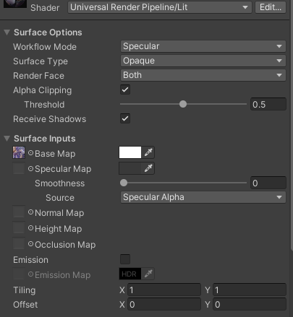

Add the corresponding texture from the 'Textures' directory in 'Base Map'.

HDRP

Go to the ‘Materials’ folder and change all the materials to 'HDRP/Lit', with these settings:

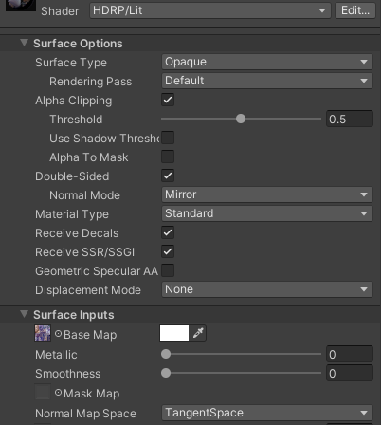

Add the corresponding texture from the 'Textures' directory in 'Base Map'.

